**Design Phase And Testing Phase Document : Parcel Delivery**

**DOCUMENTATION OF USE CASE DIAGRAM**

* Actors in the use case diagram are user, guest, admin, pick up staff, delivery staff.
* The use cases are signup, book consignment, search service availability, payment, track status, register compliant, give feedback, view booking detail, login/logout, edit employee details, review feedback, pickup, delivery, non-delivery details.
* The actor use the use case are denoted by arrow.
* The signup use case helps user in registering an account by taking details of the user.
* Then the user can login and books consignment and can also search availability of the pick up staff.
* The track status helps the user to track his/her consignment.
* The complaint use case is used to raise a complaint at the time of delivery.
* Once the delivery is successful the feedback use case is used to give feedback by the user.

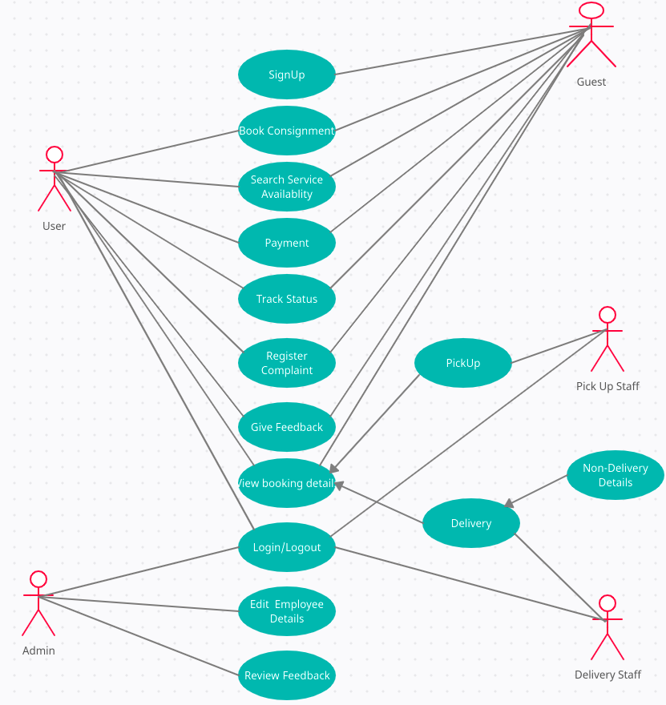

**DOCUMENTATION OF CLASS DIAGRAM**

**CUSTOMER**

* The customer have attributes like customer id, name, email, address and password.
* The customer can be added in to the parcel delivery system by registering, we can search for particular customer using this id.

**REGISTRATION**

* The registration have attributes like user id, name, address, email, consignment details and status of the consignment.
* The user who are registered are added to the system and we can search for particular user based on id.

**COURIER**

* The courier have attributes such as courier id, type, destination and the product id inside the courier.
* The user can add courier for delivery and also can make required changes according to his preference and can also cancel the courier delivery.

**DELIVERY**

* The delivery have attributes like delivery id, address, description of delivery, date and type of delivery.
* The user can add courier for delivery and also can make required changes according to his preference and can also cancel the consignment delivery.

**TRACKING**

* The tracking have attributes like user id, tracking id, name, location, email.
* The user can track his consignment based on his user id and identify the location where consignment is present.

**COMPLAINT**

* The complaint have attributes such as complaint id, user id, name and complaint description.
* The user can make a complaint based on the consignment delivery, user can also edit the complaint whenever required and also delete the complaint if it is resolved.

**FEEDBACK**

* The feedback have attributes such as feedback id, description, user id, user name.
* After the successful delivery the user can give the feedback based on his experience.

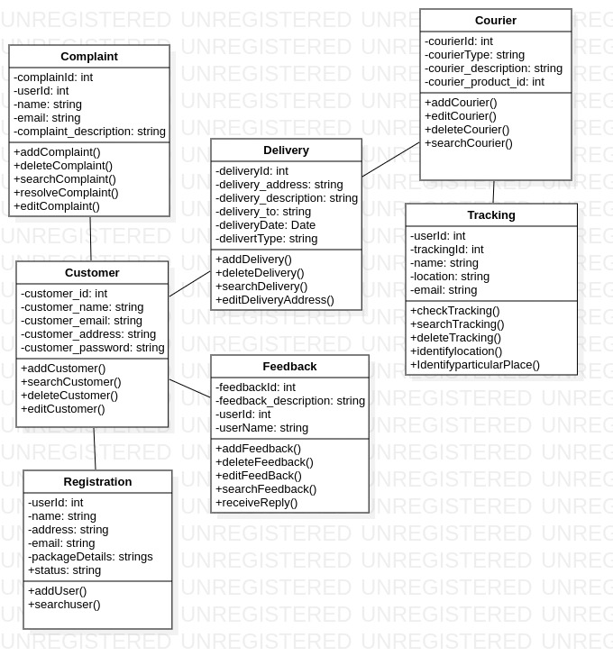

**DOCUMENTATION OF SEQUENCE DIAGRAM**

* The admin will be viewing the consignment details which are to be send for delivery.
* Based on the consignment details the admin will be checking for the delivery man details
* If there are no delivery staff available the admin have the ability to remove the consignment delivery.
* If delivery staff are available then the delivery man will be given delivery details and checking the user status.
* On the other side the user will be tracking the delivery details.
* Once the delivery is successful the user will be giving feedback.

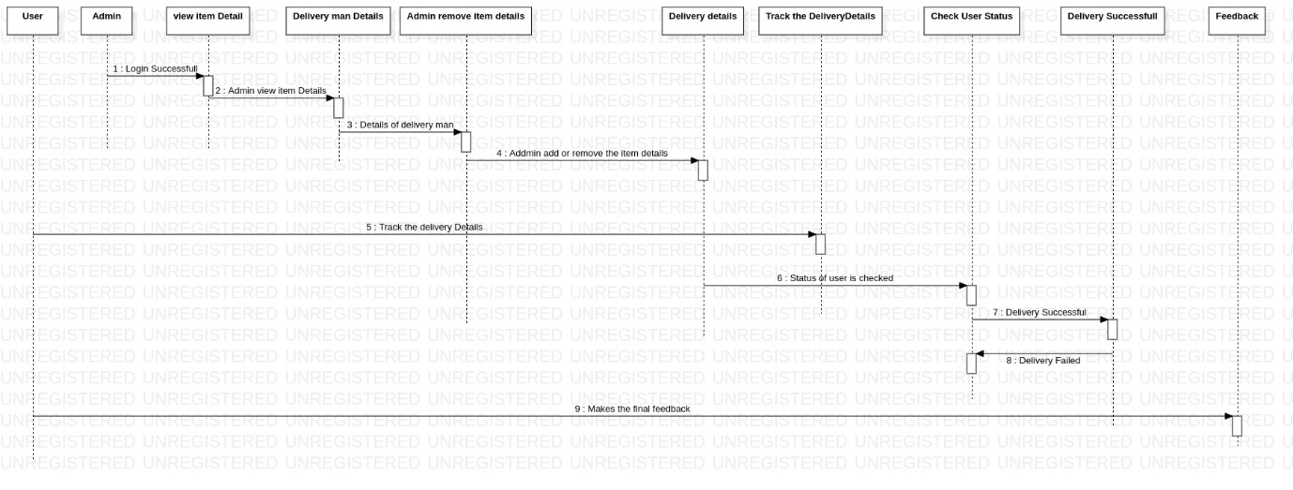

**DOCUMENTATION OF COLLABARATION DIAGRAM**

* The user, admin delivery details, tracking of delivery and feedback all are in sequence.
* The user will be booking his/her consignment for delivery.
* Based on the user details the admin will be checking for the delivery staff and sends the consignment for delivery.
* The user will be tracking the consignment and once the delivery is successful the user can submit the feedback.

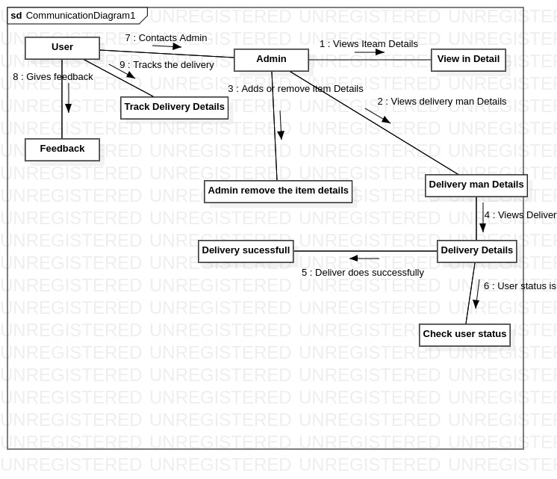

**DOCUMENTATION OF STATE CHART DIAGRAM**

* The states of parcel delivery system are shown in the state chart diagram.
* Adding items represents the user creating order for the delivery of users consignment.
* In the calculating state the admin will be calculating the weight and amount for the delivery of consignment.
* Once the calculating state is completed the consignment is ready for delivery in the dispatching state.
* The user will be tracking his order in the tracking order consignment state.
* Once the delivery is successful then the system is in shipped state.
* The feedback state is meant for the user to give his feedback.

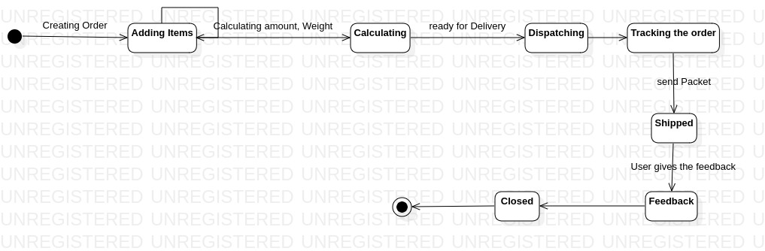

**DOCUMENTATION OF ACTIVITY DIAGRAM**

* The activities in the parcel delivery system are shown in the figure below.
* The user will be creating his new package for delivery in the first phase of the system.
* Then the user enters the delivery details and consignment details, based on the delivery and consignment details the admin will be verifying users address and calculates the shipping cost.
* The user will be selecting his delivery requirements in the next phase and based on his requirements the consignment id and shipping label is generated.
* The package is then scheduled for delivery pick up and will be sent for delivery, based on the pick up staff details the user can track consignment and can give feedback after delivery is successful.

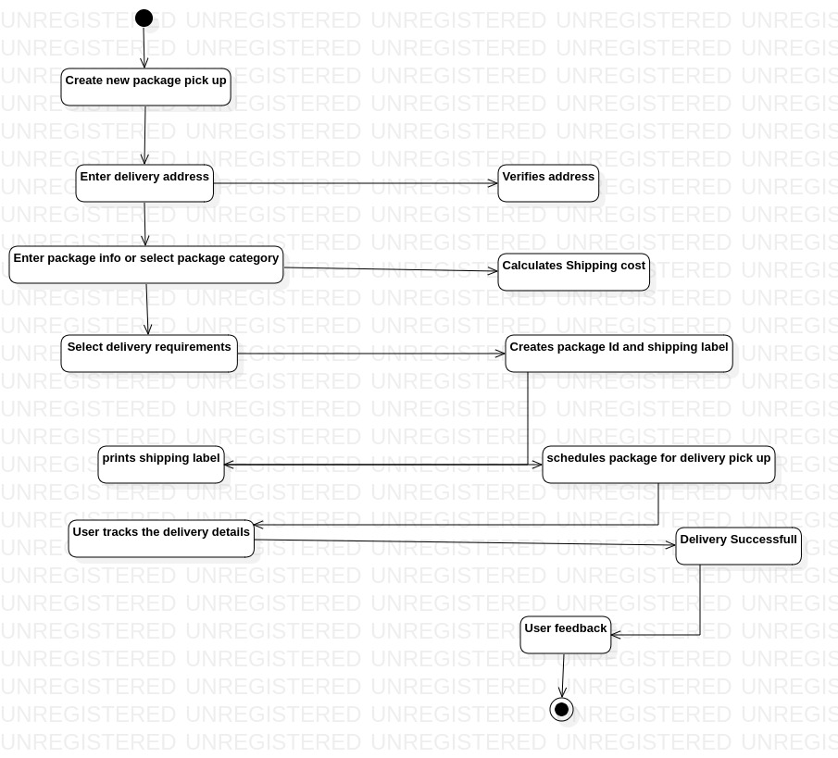

**DOCUMENTATION OF COMPONENT DIAGRAM**

* The components in the parcel delivery system are shown in the below figure.
* The infrastructure of parcel delivery system is consisting of all the details regarding the consignment delivery which is depending on the data base server.

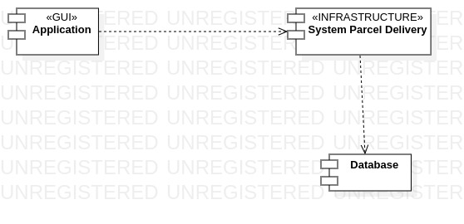

**DOCUMENTATION OF DEPLOYMENT DIAGRAM**

* The device node is the data base server and application server and execution environment node are web server.
* Inside the application server all the details entered by the user in the web server are processed and based on the details entered by the user the data has been stored inside the database server.

